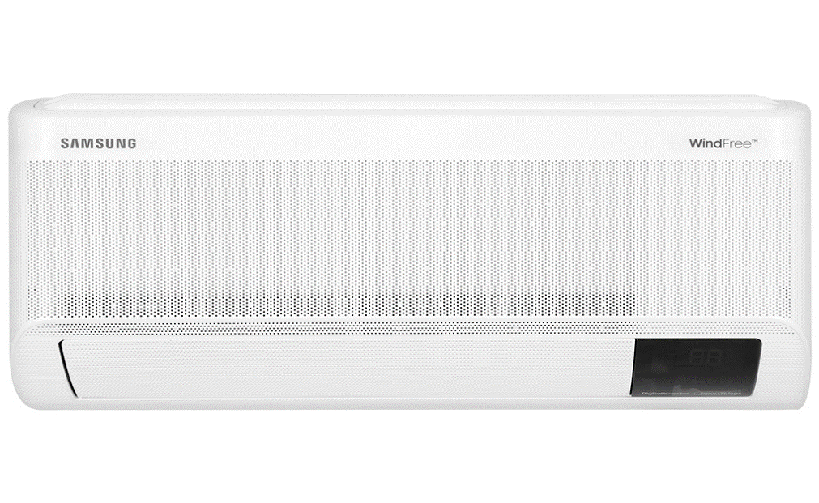

**9.990.000₫**~~11.690.000₫~~ (-14%)

**Promotion worth 1,300,000 VND**

Prices and promotions may end earlier than expected

first

Choose 1 of the promotions:

- No copper pipes and supplies will be given away.  
- Delivery only, no installation.

- Free Combo of materials (Wiring from indoor unit to outdoor unit, Simili, free up to 5 meters of copper pipes, water pipes) worth 850,000 VND (click to see details), - Free installation and [vacuuming](https://www.dienmayxanh.com/khuyen-mai/tang-vat-tu-cho-may-lanh-khong-lo-ve-phi-1234204) labor worth 450,000 VND

**Technical specifications Samsung Inverter air conditioner 1 HP AR10CYFAAWKNSV**

* Machine Type:

1 way (cooling only) With Inverter

* Cooling capacity:

1 HP - 9,000 BTU

* Effective cooling range:

Under 15m² (from 30 to 45m³)

* Dust filter, antibacterial, deodorant:

Copper Anti-bacteria Filter

* Power saving technology:

Digital Inverter BoostEco

* Rapid cooling:

Fast Cooling

* Utilities:

Good Sleep mode Wind-Free mode for comfortable cold air Dehumidification function Auto Clean function Self-cleaning function On-off timer Smart refrigeration AI Auto Cooling Temperature display screen on the indoor unit Auto-start Restarts when there is power. Remote control via SmartThings application

* Power consumption:

0.84 kW/h 5 stars (Energy efficiency 4.56)

* Cooler:

Length 68.2 cm - Height 29.9 cm - Thickness 21.5 cm - Weight 8 kg

* Outdoor:

Length 73 cm - Height 47.5 cm - Thickness 28 cm - Weight 18.7 kg

Introducing the company 

- A brand from Korea, founded in 1938.  
- Samsung is a multi-industry corporation, with a high level of brand recognition on a global scale.  
- Samsung's products range from mobile devices, home appliances, electronics,...  
- With the strength of being the brand of a global corporation, the quality of products always reaches the highest level of perfection. , good warranty should be trusted by customers around the world.

[***Samsung Inverter 1 HP AR10CYFAAWKNSV air conditioner***](https://www.dienmayxanh.com/may-lanh/samsung-inverter-1-hp-ar10cyfaawknsv#2-gia)***is equipped with Copper Anti-bacteria Filter for optimal dirt and bacteria filtration efficiency. Furthermore, the air conditioner can also blow pleasant wind and cool quickly with the company's exclusive Wind-Free technology.***

**Design**

**Cooler:**

- The indoor unit has a **unique design** with a **mask layer with many tiny hole patterns** , durable material and white paint, harmoniously coordinating with other furniture inside the room.

- **The temperature display screen** is compactly designed and located to the right of the air conditioner's flap, so users can easily observe each time the temperature is adjusted.

**Outdoor:**

- The outdoor unit of [Samsung air conditioner](https://www.dienmayxanh.com/may-lanh-samsung) has a familiar horizontal rectangular shape with a sturdy shell and is able to withstand elements outside the installation environment.

- The heatsinks of the condenser and condenser are both made of **aluminum** . In addition, the gas pipes are also made **of durable pure copper** and enhance the ability to transfer heat quickly and stably during [air conditioner](https://www.dienmayxanh.com/may-lanh) operation.

**Refrigeration technology**

- Samsung air conditioner operates with **a capacity of 1 HP** , meeting the cooling capacity for a room area **under 15m²** .

- **AI Auto Cooling smart cooling technology** : The air conditioner has a built-in sensor capable of analyzing the set temperature according to usage habits and other conditions in the room, then automatically **selects the cooling mode. suitable** to **bring the coolest and most comfortable atmosphere** for users.

- **Fast Cooling technology** : After activating Fast Cooling mode, the air conditioner will increase fan speed and operate at the highest compressor capacity, to quickly **reduce the room temperature** to the temperature set by the user. placed, can even **blow cold air up to 15m away** . Thanks to that, users **feel the cold immediately** after using this mode.

*\*Video is for illustration purposes only*

**Air blowing mechanism**

- This [Samsung Inverter 1 HP air conditioner](https://www.dienmayxanh.com/may-lanh-samsung?g=may-lanh-inverter) can control **the air flaps up, down,** **left and right automatically** .

- [Wind-Free mode](https://www.dienmayxanh.com/kinh-nghiem-hay/wind-free-cong-nghe-lam-lanh-cua-tuong-lai-1068729) : Capable of blowing air through **23,000 tiny holes** designed on the front of the indoor unit, thereby **creating a super smooth airflow and minimizing uncomfortable cold conditions** for people. use. This mode also helps maintain a stable temperature in the room and helps the air conditioner use electricity more economically.

*\*Video is for illustration purposes only*

**Power saving technologies**

- Samsung AR10CYFAAWKNSV air conditioner is equipped with energy-saving Inverter technology.

- [Digital Inverter Boost technology](https://www.dienmayxanh.com/kinh-nghiem-hay/may-nen-inverter-8-cuc-tren-may-lanh-samsung-2016-817570) : Helps the compressor operate at high capacity but still provides energy saving efficiency of up to 68%, while also supporting the air conditioner to **operate stably** and **cool up to 43% faster** .

- **Eco mode** : After activating Eco mode, this [Samsung 1 HP air conditioner](https://www.dienmayxanh.com/may-lanh-samsung?g=1-hp) has the ability to automatically adjust cooling capacity to maintain the optimal temperature inside the room, contributing to both saving electricity and ensure user comfort.

- The product consumes about [0.84 kW/h](https://www.dienmayxanh.com/kinh-nghiem-hay/cong-suat-tieu-thu-dien-toi-da-855107) , achieving energy efficiency of **4.56 (5 stars)** .

[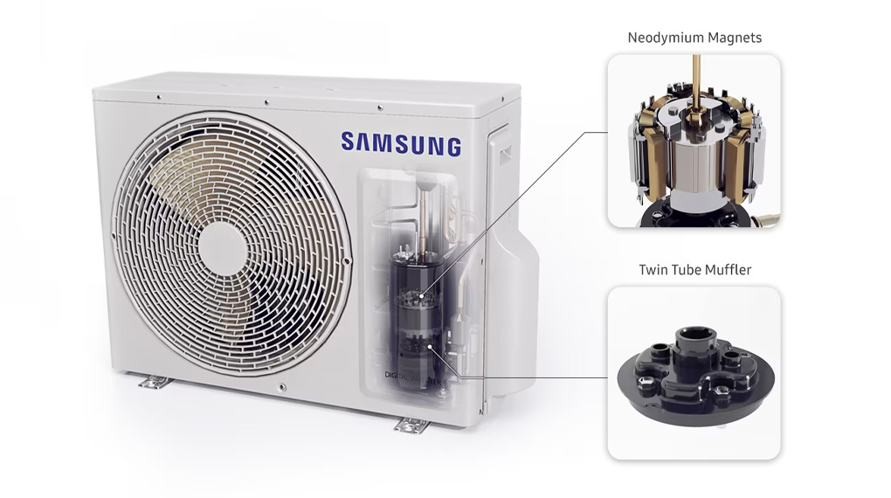](https://cdn.tgdd.vn/Products/Images/2002/304225/samsung-inverter-1-hp-ar10cyfaawknsv-100723-054246.jpg)

*\*Video is for illustration purposes only*

**Air filtration ability - health**

**Copper Anti-bacteria Filter** : Is an antibacterial copper molecular filter with the ability to optimally kill bacteria and remove dirt, thereby **bringing fresh and safe air** to users. Furthermore, this filter is also **designed to be easy to remove** , convenient for users when cleaning the machine.

**Utilities**

- **Remote control via SmartThings application** : With the SmartThings application, users can **control the functions and temperature of the air conditioner remotely** on [the phone](https://www.dienmayxanh.com/dien-thoai) easily and whenever they want.

- **Dehumidifying function** : Dehumidifies and helps the air inside the room **dry** , to reduce the feeling of discomfort for users on rainy, humid days.

- **Auto Clean self-cleaning function** : After turning off the machine, the fan inside the condenser still operates to blow away dust and dry the condenser, thereby **helping the condenser operate effectively and maintain good durability.** than.

- **Good Sleep mode** : Set by default to **an 8-hour sleep cycle** , meaning that the Samsung air conditioner will gradually reduce the temperature to **put the user into deep sleep** , then slowly increase the temperature to **avoid causes a cold feeling** for the user during sleep time at night.

*In short, the Samsung Inverter 1 HP AR10CYFAAWKNSV air conditioner has the ability to blow out comfortable cold air, suitable for use by children and the elderly. In addition, the machine can also cool quickly and bring energy savings to users.*